Delhi Public School

Faridabad

Computer Science

Practical File

**Binary Search**

Shashank Sengar

#include<iostream.h>

int Bsearch(int [],int ,int);

int main()

{

int AR[50],ITEM,N,index;

cout<<"Enter desired array size" ;

cin>> N;

cout<<"enter sorted array(ascending order) \n";

for(int i =0;i<N;i++)

cin>>AR[i];

cout<<"enter element to be searched";

cin>>ITEM;

index=Bsearch(AR,N,ITEM);

if(index==-1)

cout<<"\n sorry!! given element does not exist in the array ";

else

cout<<"element found at"<<(index+1)<<" position";

return 0;

}

int Bsearch(int Ar[],int size,int item)

{ int mid,beg=0,last=size-1;

while(beg<=last)

{mid=(beg+last)/2;

if(item==Ar[mid])return mid;

else if(item>Ar[mid])beg=mid+1;

else last=mid-1 ;

}

return -1;

}

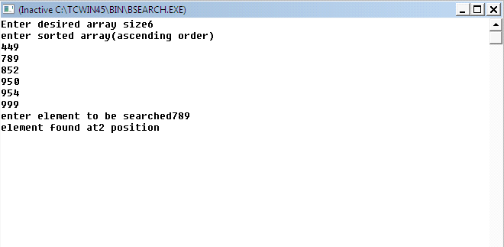

**Insertion Sort**

#include<iostream.h>

#include<limits.h>

void inssort(int[],int);

int main()

{

int AR[50],N;

cout<<"How many elements you want to enter(max 50)";

cin>>N;

cout<<"\n Enter array elements ...";

for(int i=1;i<=N;i++)

cin>>AR[i];

inssort(AR,N);

cout<<"The array now is as shown below...\n";

for (i=1;i<=N;i++)

cout<<AR[i]<<" ";

cout<<endl;

return 0;

}

void inssort(int AR[],int size)

{

int tmp,j;

AR[0]=INT_MIN;

for(int i=1;i<=size;i++)

{

tmp=AR[i];

j=i-1;

while(tmp<AR[j])

{AR[j+1]=AR[j];

j--;

}

AR[j+1]=tmp;

}

}#include<iostream.h>

#include<limits.h>

void inssort(int[],int);

int main()

{

int AR[50],N;

cout<<"How many elements you want to enter(max 50)";

cin>>N;

cout<<"\n Enter array elements ...";

for(int i=1;i<=N;i++)

cin>>AR[i];

inssort(AR,N);

cout<<"The array now is as shown below...\n";

for (i=1;i<=N;i++)

cout<<AR[i]<<" ";

cout<<endl;

return 0;

}

void inssort(int AR[],int size)

{

int tmp,j;

AR[0]=INT_MIN;

for(int i=1;i<=size;i++)

{

tmp=AR[i];

j=i-1;

while(tmp<AR[j])

{AR[j+1]=AR[j];

j--;

}

AR[j+1]=tmp;

}

}

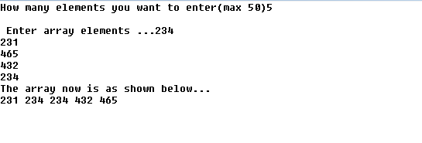

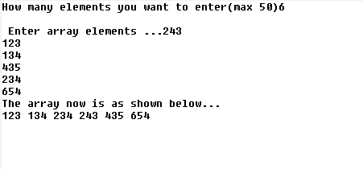

**Bubble Sort**

#include<iostream.h>

void BubbleSort(int[],int);

int main()

{

int AR[50],N;

cout<<"How many elements You wnt to enter (max. 50)...\n";

cin>>N;

cout<<"Enter array elements...\n";

for(int i=0;i<N;i++)

cin>>AR[i];

BubbleSort(AR,N);

cout<<"The Sorted array is as shown below...\n";

for(i=0;i<N;i++)

cout<<AR[i]<<" ";

return 0;

}

void BubbleSort(int AR[],int size)

{

int tmp;

for(int i=0;i<size;i++)

for(int j=0;j<(size-1)-i;j++)

if(AR[j]<=AR[j+1])

{tmp=AR[j];

AR[j]=AR[j+1];

AR[j+1]= tmp;

}

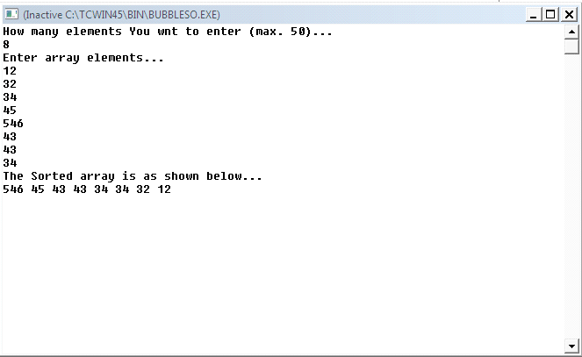

**Selection Sort**

#include<iostream.h>

void selsort(int [],int) ;

int main()

{int ar[50],n;

cout<<"enter no. of elements(max.50):";

cin>>n;

cout<<"\nenter array elements ";

for(int i=0;i<n;i++)

{cin>>ar[i]; }

selsort(ar,n);

cout<<"\nthe sorted array is shown below\n";

for( i=0;i<n;i++)

{cout<<ar[i]<<" ";

}

cout<<endl;

return 0;

}

void selsort(int ar[],int p)

{int small,pos,tmp;

for(int i=0;i<p;i++)

{small=ar[i];

pos=i;

for(int j=i+1;j<p;j++)

{if(ar[j]<small)

{small=ar[j];

pos =j;

}

}

tmp=ar[i];

ar[i]=ar[pos];

ar[pos]=tmp;

}}

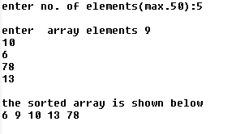

**Asc. Array A + Desc. Array B= Asc. Array C**

#include<iostream.h>

void merge(int[],int[],int,int,int[]);

int main()

{

int ar[50],AR[50],ne[50],h,k,i,size=0;

cout<<"Enter no.of elements in array1 (max 50)... \n";

cin>>h;

cout<<"Enter no.of elements in array2 (max 50)... \n";

cin>>k;

cout<<"Enter elements of array1(asc. order)...";

for(i=0;i<h;i++)

cin>>ar[i];

cout<<"Enter elements of array2(desc.order)...";

for(i=0;i<k;i++)

cin>>AR[i];

merge(ar ,AR ,h,k,ne);

cout<<"new array is...";

size=h+k;

for(i=0;i<size;i++)

cout<<ne[i]<<" ";

return 0;

}

void merge(int ar[],int AR[],int size1,int size2,int ne[] )

{int a=0,b=size2-1;

for(int i=0;i<(size1+size2)-1 && a<size1 && b>=0;i++)

{if(ar[a]<AR[b])

ne[i]=ar[a++];

else

ne[i]=AR[b--];

}

if(a<size1)

{for(int j=i;a<size1-1;j++)

ne[j]=ar[a++];}

else

{for(int k=i;b>=0;k++)

ne[k]=AR[b--];}}

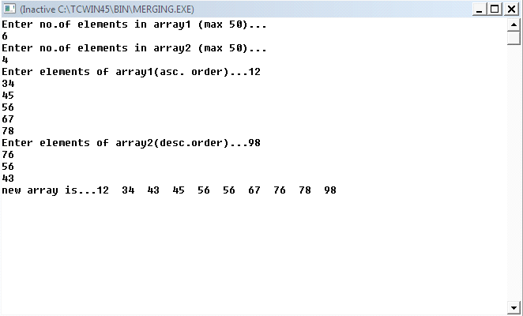

**Linear Search**

#include<iostream.h>

int Lsearch(int [],int , int);

int main()

{int AR[50],ITEM,N,index;

cout<<"Enter desired array size(max. 50)...";

cin>>N;

cout<<"\n EnterArray elements \n";

for(int i=0;i<N;i++)

cin>>AR[i];

cout<<"\n Enter element to be searched for...";

cin>>ITEM;

index=Lsearch(AR,N,ITEM);

if(index==-1)

cout<<"\n Sorry!!Given element does not exist...";

else

cout<<"Element exist at position:"<<(index+1);

return 0;

}

int Lsearch(int AR[],int size,int item)

{for(int i=0;i<size;i++)

{if(AR[i]==item)

return i;

}

return -1;

}

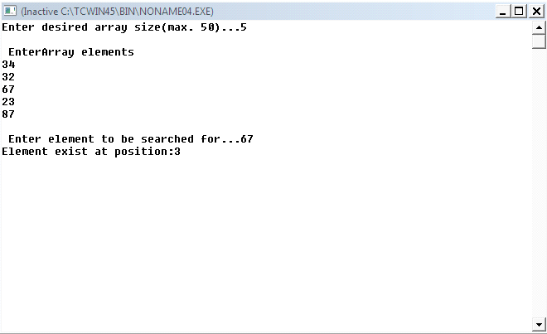

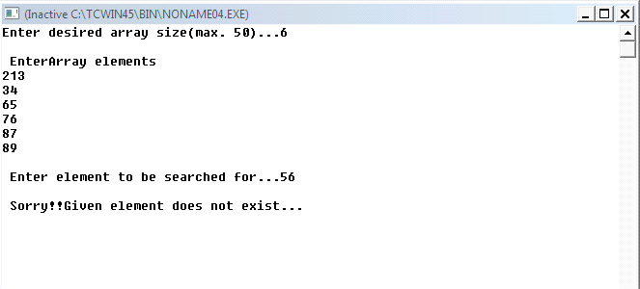

**Student Result- Array**

#include<iostream.h>

#include<stdio.h>

class student

{

private:

int roll;

char name[25];

float marks[3];

public:

float per;

char grade;

void calc();

void getdata();

void putdata();

};

void student :: getdata()

{cout<<"Enter Name , roll no. , marks of 3 subjects orderwise";

gets (name);

cin>>roll;

for(int k=0;k<3;k++)

cin>>marks[k];

}

void student :: calc()

{int sum=0;

for(int i=0;i<3;i++)sum+=marks[i];

float tmp=sum*100;

per=tmp/300;

if(per<50)

grade='E';

else if(per>=50&&per<60)

grade='D';

else if(per>=60&&per<75)

grade='C';

else if(per>=75&&per<90)

grade='B';

else grade='A';

}

void student::putdata()

{cout<<"Data of roll no "<<roll<<"is \n"<<"Name: \n";

puts(name);

for (int j=0;j<3;j++)

cout<<"Marks of subject "<<(j+1)<<":"<<marks[j]<<endl;

cout<<"Percentage :"<<per<<endl;

cout<<"Grade :"<<grade;

}

void main()

{int p;

student s[2];

for(p=0;p<2;p++)

s[p].getdata();

for(p=0;p<2;p++)

s[p].calc();

for(p=0;p<2;p++)

s[p].putdata();

}

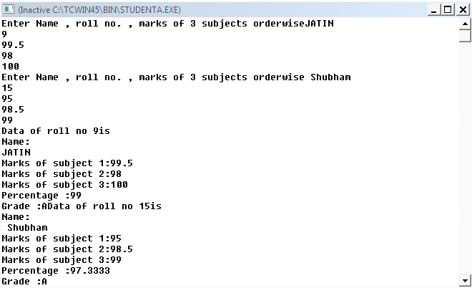

**Sum of Matrices**

#include<iostream.h>

#include<process.h>

int main()

{

int a[10][10] ,b[10][10],c[10][10];

int i,j,n,m,p,q;

cout<<"\n Input row & column of matrix-A ";

cin>>m>>n;

cout<<"\n Input row & column of matrix-B ";

cin>>p>>q;

if((m==p) && (n==q))

{cout<<"\n Input matrix-A \n";

for(i=0;i<m;i++)

{cout<<"\n";

for(j=0;j<n;j++)

{cout<<"\t";

cin>> a[i][j];

}}

cout<<" Input matrix-B \n";

for(i=0;i<p;i++)

{cout<<"\n";

for(j=0;j<q;j++)

{cout<<"\t";

cin>> b[i][j];

}}

for(i=0;i<m;i++)

{for(j=0;j<n;j++)

{

c[i][j]=a[i][j]+b[i][j];

}}

cout<<"Sum of two matrices is\n";

for(i=0;i<m;i++)

{cout<<"\n";

for(j=0;j<n;j++)

{cout<<c[i][j]<<"\t";

}

}}

else

cout<<"can't be added";

return 0;

}

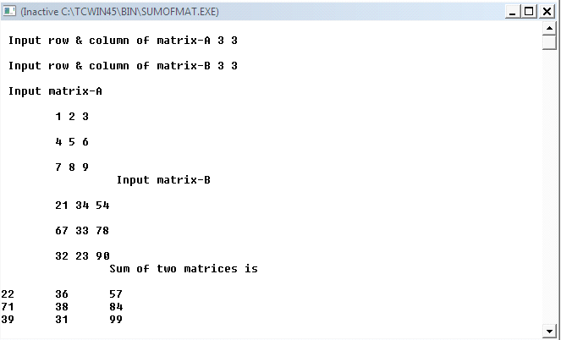

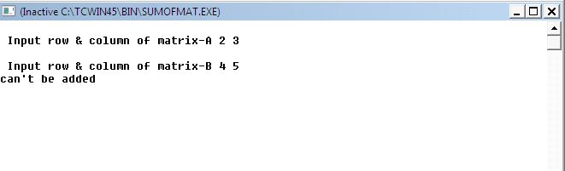

**Queue**

#include<iostream.h>

#include<conio.h>

#include<process.h>

struct QUEUE

{ int empno;

float sly;

QUEUE *next;

} *FRONT, *REAR, *np, *npr;

void create(int em, float sa)

{

npr=new QUEUE;

npr->empno=em;

npr->sly=sa;

npr->next=NULL;

if (FRONT == NULL)

FRONT=REAR=npr;

else

{

REAR->next =npr;

REAR = npr;

}

}

void del()

{

if (FRONT == NULL)

cout<<"\nUnderflow!!!\n";

else

{

npr=FRONT;

FRONT=FRONT->next;

cout<< npr->empno<<"\t"<<npr->sly<<endl;

delete npr;

}

}

void disp (QUEUE *np)

{

while(np!=NULL)

{

cout<<"\n\t"<<np->empno<<"\t"<<np->sly;

np=np->next;

}

}

void main()

{

FRONT=REAR=NULL;

int a,empno;

float s;

c:

clrscr();

cout<<"\n MENU \n";

cout<<"1. ADD ELEMENT\n";

cout<<"2. DELETE ELEMENT\n";

cout<<"3. DISPLAY CONTENTS\n";

cout<<"4. EXIT\n";

cout<<"Enter your choice: ";

cin>>a;

switch(a)

{

case 1: cout<<"\n Input the information :";

cout<<"\n Input the Emp No. ";

cin>>empno;

cout<<" Input the Salary ";

cin>>s;

create(empno, s);

cout<<"\n Record Added Successfully!";

getch();

break;

case 2: cout<<"\n The Element to be deleted is: ";

del();

getch();

break;

case 3: cout<<"\n The Linked Queue is... ";

disp(FRONT);

getch();

break;

case 4: exit(0);

break;

default: cout<<"\n Entering wrong option!\n";

getch();

}

goto c;}

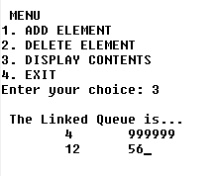

**Transpose of Matrix**

#include<iostream.h>

#include<stdlib.h>

int main()

{ int a[3][3],b[3][3],i,j;

cout<<"\nenter the elements of matrix:";

for( i=0;i<3;i++)

for( j=0;j<3;j++)

cin>>a[i][j];

cout<<"given matrix is";

for(i=0;i<3;i++)

{cout<<"\n";

for(j=0;j<3;j++)

cout<<a[i][j];

cout<<"\n";

}

cout<<"transpose of the given matrix is";

for(i=0;i<3;i++)

{cout<<"\n";

for(j=0;j<3;j++)

{ b[i][j]=a[j][i];

cout<<b[i][j]<<" " ;}

return 0;}

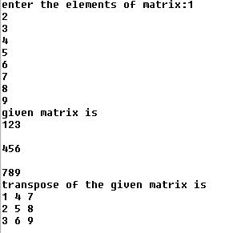

**Stacks- Push & Pop**

#include<iostream.h>

#include<stdlib.h>

#include<string.h>

#include<process.h>

#include<stdio.h>

struct node

{

int rno;

char name[30];

node*link;

}*top;

ins(int a, char b[30])

{node *np=new node;

if(np==NULL)

{

cout<<"can't allocate memory";

exit(0);

}

np->rno=a;

strcpy(np->name,b);

np->link=NULL;

if(top==NULL)

top=np;

else

{np->link=top;

top=np;

}

}

void display(node*np)

{

while(np!=NULL)

{ cout<<"\n";

cout<<np->rno<<np->name<<"\n";

np=np->link;

}

}

del(int d,char w[30])

{

node *np=new node;

np->rno=d;

strcpy(np->name,w);

if(top==NULL)

{cout<<"underflow";

exit(0);}

else

{np=top;

top=top->link;

delete np;}

}

void main()

{int r;

char c,ch,n[30];

do

{cout<<"enter roll no";

cin>>r;

cout<<"\n enter name";

gets(n);

ins(r,n);

cout<<"do u want enter more" ;

cin>>ch;

}while(ch=='y'||ch=='Y');

cout<<"the list is"<<"\n";

display(top);

do

{

cout<<"do u want to delete";

cin>>c;

if(c=='y'||c=='Y')

{cout<<"now deletion begins";

del(r,n);}

display(top);

}while(c=='y'||c=='Y') ;}

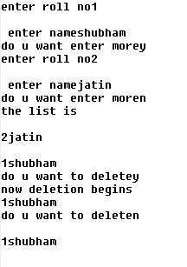

**Pair Swapping - Array**

#include<iostream.h>

#include<process.h>

void swaparray(int a[],int n)

{int tmp,i,j;

if(n%2==0)

{ for(i=0;i<n;i+=2)

{j=i+1;

tmp=a[i];

a[i]=a[j];

a[j]=tmp;

}

}

else

{cout<<"array cannot be swapped(n is odd)!!!!!";

exit(0);}

}

void main()

{int a[50],n,i;

cout<<"enter the size of the array";

cin>>n;

cout<<"\n";

cout<<"enter the elements of the array\n";

for(i=0;i<n;i++)

{cin>>a[i];

}

swaparray(a,n);

cout<<"the array now is ";

cout<<"\n";

for(i=0;i<n;i++)

{ cout<<a[i];

cout<<"\t";

}}

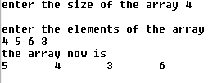

**Swap Array**

#include<iostream.h>

void swaparr(int a[], int n)

{int i,j,tmp,mid=n/2;

if(n%2==0)

j=mid ;

else

j=mid+1;

for(i=0;i<mid;i++,j++)

{tmp=a[i];

a[i]=a[j];

a[j]=tmp;

}

}

void main()

{int a[50],n,i;

cout<<"enter the size of the array";

cin>>n;

cout<<"\n";

cout<<"enter the elements of the array\n";

for(i=0;i<n;i++)

{cin>>a[i];

}

swaparr(a,n);

cout<<"the array after swapping is";

for(i=0;i<n;i++)

{cout<<a[i];

cout<<endl;

}}

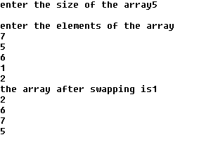

**Insertion-Deletion Array**

#include<iostream.h>

#include<stdio.h>

#include<process.h>

int findpos(int[],int,int);

int lsearch(int ar[50],int size,int item)

{

for(int i=0;i<size;i++)

{if(ar[i]==item) return i;

}

return -1;

}

int main ()

{

int ar[50],item,ITEM,n,p,ip;

cout<<"how many elements do u want to create array with";

cin>>n;

cout<<"\nenter array elements (must be sorted in asce order)";

for(int i=0;i<n;i++)

cin>>ar[i];

char ch='y';

while(ch=='y'||ch=='Y')

{cout<<"\nenter element to be inserted";

cin>>item;

if(n==50)

{cout<<"overflow";

exit(0);

}

p=findpos(ar,n,item);

for(i=n;i>p;i--)

{ar[i]=ar[i-1];}

ar[p]=item;

n+=1;

cout<<"\nwant to insert more elements?(y/n)";

cin>>ch;

}cout<<"the array now is as shown below";

for(i=0;i<n;i++)

cout<<ar[i]<<" ";

cout<<endl;

char c='y';

while(c=='y'||c=='Y')

{

cout<<"\nenter element to be deleted" ;

cin>>ITEM;

if(n==0)

{cout<<"underflow";

cout<<"\n";

exit(0);

}

ip=lsearch(ar,n,ITEM);

if(ip!=-1) ar[ip]=0;

else

{cout<<"sorry!! no such elementin the array\n";

break;}

cout<<"the array now is as shown below";

for(i=0;i<n;i++)

cout<<ar[i]<<" ";

cout<<endl;

cout<<"after this emptied space will be shifted to the end of the array";

for(i=ip;i<n;i++)

{

ar[i]=ar[i+1];}

n-=1;

cout<<"\nwant to delete more element?(y\n)";

cin>>c;

}

cout<<"the array now is as shown below";

for(i=0;i<n;i++)

cout<<ar[i]<<" ";

cout<<endl;

return 0;

}

int findpos(int ar[],int size ,int item)

{int pos;

if (item<ar[0]) pos=0;

else

{for(int i=0;i<size-1;i++)

{if(ar[i]<=item && item<ar[i+1] )

{pos=i+1;

break;

}

}

if(i==size-1) pos=size;

}

return pos;}

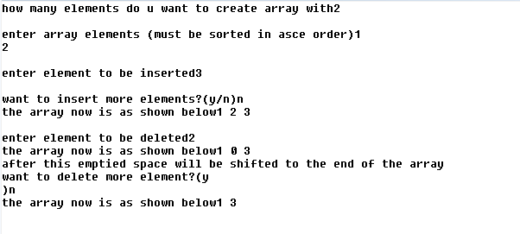

**Product of Matrix**

#include<iostream.h>

#include<process.h>

int main()

{int a[10][10],b[10][10],c[10][10],i,j,m,n,p,q,ip;

cout<<"enter row & column of matrix a:";

cin>>m>>n;

cout<<"enter row &column of matrtix b:";

cin>>p>>q;

if(n==p)

cout<<"matrices can be multiplied";

else

{cout<<"matrices can not be multiplied:";

exit(0);

}

cout<<"\n input matrix a:";

for(i=0;i<m;i++)

{for(j=0;j<n;j++)

cin>>a[i][j];

}

cout<<"\n input matrix b:";

for(i=0;i<p;i++)

{for(j=0;j<q;j++)

cin>>b[i][j];

}

cout<<"matrix a is:";

for(i=0;i<m;i++)

{cout<<"\n";

for(j=0;j<n;j++)

cout<<a[i][j];

}

cout<<"matrix b is :";

for(i=0;i<p;i++)

{cout<<"\n";

for(j=0;j<q;j++)

cout<<b[i][j];

}

for(i=0;i<m;i++)

{for(j=0;j<q;j++)

{c[i][j]=0;

for(ip=0;ip<n;ip++)

c[i][j]+=(a[i][ip]*b[ip][j]);

}}

cout<<"\n product of matrix a&b is";

for(i=0;i<m;i++)

{cout<<"\n";

for(j=0;j<q;j++)

cout<<c[i][j]<<" ";

}

return 0;}

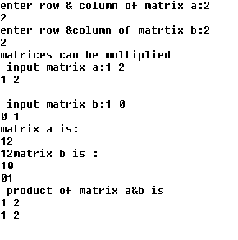

**Modifying a File**

#include<iostream.h>

#include<fstream.h>

#include<stdio.h>

#include<string.h>

#include<stdlib.h>

class stu{ int rno;

char name[25];

char clas[4];

float marks ;

char grade;

public:

void getdata()

{

cout<<"rollno";

cin>>rno;

cout<<"name";

cin>>name;

cout<<"class";

cin>>clas;

cout<<"marks";

cin>>marks;

if(marks>=75) grade='A';

else if(marks>=60) {grade='B'; }

else if(marks>=50){ grade='C'; }

else if(marks>=40) { grade='D';}

else {grade='f';}

}

void putdata()

{

cout<<"roll no"<<rno<<"\tname:"<<name;

cout<<"\nmarks:"<<marks<<"\tgrade:"<<grade ;

cout<<endl;

}

int getrno()

{return rno;}

void modify();

}s1,stud;

void stu::modify()

{cout<<"rollno:"<<rno<<endl;

cout<<"name:"<<name<<"\tclass:"<<clas;

cout<<"\tmarks"<<marks<<endl;

cout<<"enter new details."<<endl;

char nm[20]=" ",cl[4]=" ";

float mks;

cout<<"new name:(enter '.'to retain old one)";

cin>>nm;

cout<<"new class :(enter '.' to retain old one)";

cin>>cl;

cout<<"new marks:(enter '.' to retain old one)";

cin>>mks;

if(strcmp(nm,".")!=0)

strcpy(name,nm);

if(strcmp(cl,".")!=0)

strcpy(clas,cl);

if(mks!=-1)

{marks=mks;

if(marks>=75) {grade='A'; }

else if(marks>=60) {grade='B';}

else if(marks>=50) {grade='C';}

else if(marks>=40) {grade='D';}

else {grade='f';}

}

}

int main()

{ fstream fio("stu.dat",ios::in|ios::out|ios::binary);

int rno;char ch='y';

long pos; char found='f';

while(ch=='y'||ch=='Y')

{

s1.getdata();

fio.write((char *)&s1,sizeof(s1));

cout<<"Record Added Successfully\n";

cout<<"Do you wish to enter more?(y/n)";

cin>>ch;

}

cout<<"enter rollno of student whose recordis to be modified\n";

cin>>rno;

fio.seekg(0);

while(!fio.eof())

{ pos=fio.tellg();

fio.read((char*)&s1,sizeof(s1));

if(s1.getrno()==rno)

{ s1.modify();

fio.seekg(pos);

fio.write((char*)&s1,sizeof(s1));

found='t';

break;

}

}

if (found=='f')

cout<<"record not found !!!\n";

fio.seekg(0);

cout<<"now the file contains\n";

while(!fio.eof())

{ fio.read((char*)&stud,sizeof(stud));

stud.putdata();

}

fio.close();

return 0;}

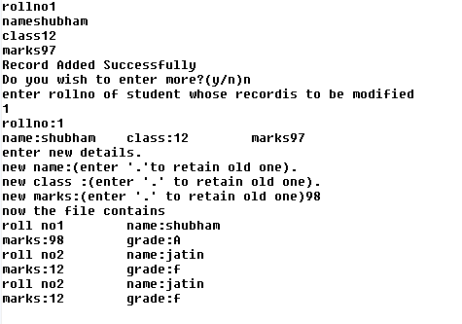

**Calculate Simple Interest**

#include<iostream.h>

#include<stdio.h>

#include<math.h>

class client

{

int time;

char name[25];

int code;

float rate;

int amount;

float interest;

public:

void getdata()

{cout<<"enter name of client"<<"\n";

gets(name);

cout<<"enter code"<<"\n";

cin>>code;

cout<<"enter time duration"<<"\n";

cin>>time;

cout<<"enter interest rate"<<"\n";

cin>>rate;

cout<<"enter your principal amount"<<"\n";

cin>>amount;

}

void disp()

{ cout<<"your code is"<<code<<"\n";

cout<<"the client name is";

puts(name);

cout<<"\n";

cout<<"your time duration is:"<<time<<"years"<<"\n";

cout<<"your interest rate is:" <<rate<<"% per annum"<<"\n";

cout<<"your principal amount is :"<<amount <<"\n";

cout<<"your simple interest is:"<<interest<<"\n";

cout<<endl;

}

void computesi()

{ float p=rate*time*amount;

interest=p/100;

}

}s1[2];

void main()

{int p;

for(p=0;p<2;p++)

{s1[p].getdata(); }

for(p=0;p<2;p++)

{s1[p].computesi();}

for(p=0;p<2;p++)

{s1[p].disp();}

}

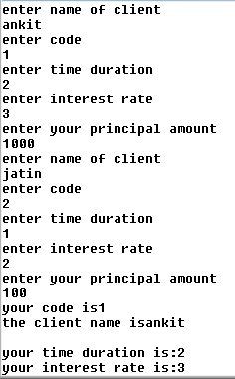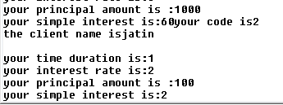

**Replacing Elements- Array**

#include<iostream.h>

void replace(int a[],int n)

{int tmp;

for(int i=0;i<n;i++)

{

if(i%2==0)

{ tmp=a[i];

a[i]=a[i+1];

a[i+1]=tmp ; }

else

a[i]=a[i];

}

}

void main()

{int a[50],n,i;

cout<<"enter the size of the array";

cin>>n;

cout<<"\n";

cout<<"enter the elements of the array\n";

for(i=0;i<n;i++)

{cin>>a[i];

}

replace(a,n);

cout<<"the aray after swapping is ";

for(i=0;i<n;i++)

{cout<<a[i];

cout<<endl;

}

}

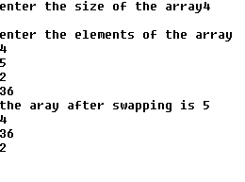

**Word Count**

#include<fstream.h>

#include<stdlib.h>

#include<string.h>

#include<stdio.h>

int main()

{void COUNT();

fstream fio("ARTICLE.TXT",ios::in|ios::out);

char ans='y';

char a[50];

while(ans=='y'||ans=='Y')

{cout<<"\nenter string:";

gets(a);

fio<<a<<endl;

cout<<"record added successfully";

cout<<"do u want to enter more ? (y/n)";

cin>>ans;

}

COUNT();

fio.close();

return 0;

}

void COUNT()

{ ifstream fin;

fin.open("ARTICLE.TXT",ios::in);

fin.seekg(0);

char word[50];

int c1=0,c2=0;

while(!fin.eof())

{fin>>word;

if(strcmp(word,"this")==0) c1++;

if(strcmp(word,"these")==0) c2++;

}

cout<<"occurence of\'this\'in file is:"<<c1;

cout<<"occurence of\'these\'in file is:"<<c2;

fin.close();

}

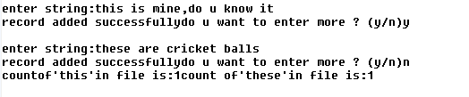

**Swapping Values**

#include<iostream.h>

int main()

{ void swap(int *x,int*y);

int a=7,b=4;

cout<<"original values \n" ;

cout<<"a="<<a<<",b="<<b<<"\n";

swap(&a,&b);

cout<<"swapped values \n";

cout<<"a="<<a<<",b="<<b<<"\n";

return 0;

}

void swap(int *x,int *y)

{ int temp;

temp=*x;

*x=*y;

*y=temp;}

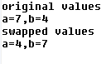

mysql> use firm;

Database changed

mysql> select * from employees;

+-------+-----------+----------+----------------+-----------+

| empid | firstname | lastname | address | city |

+-------+-----------+----------+----------------+-----------+

| 10 | ravi | kumar | raj nagar | GZB |

| 105 | harry | waltor | gandhi nagar | GZB |

| 152 | sam | tones | 33 elm st. | paris |

| 215 | sarah | ackerman | 440 us 110 | upton |

| 244 | manilla | sengupta | 24 friends st. | new delhi |

| 300 | robert | samuel | 9 5th cross. | wasington |

| 335 | ritu | tondon | sastri ng . | GZB |

| 400 | rachel | lee | 121 harisson | ny |

| 441 | peter | lee | 11 red road | pari |

| 445 | harsh | vats | xlane | y city |

+-------+-----------+----------+----------------+-----------+

10 rows in set (0.00 sec)

mysql> select * from employees where empid>400;

+-------+-----------+----------+-------------+--------+

| empid | firstname | lastname | address | city |

+-------+-----------+----------+-------------+--------+

| 441 | peter | lee | 11 red road | pari |

| 445 | harsh | vats | xlane | y city |

+-------+-----------+----------+-------------+--------+

2 rows in set (0.02 sec)

mysql> select * from employees order by empid ;

+-------+-----------+----------+----------------+-----------+

| empid | firstname | lastname | address | city |

+-------+-----------+----------+----------------+-----------+

| 10 | ravi | kumar | raj nagar | GZB |

| 105 | harry | waltor | gandhi nagar | GZB |

| 152 | sam | tones | 33 elm st. | paris |

| 215 | sarah | ackerman | 440 us 110 | upton |

| 244 | manilla | sengupta | 24 friends st. | new delhi |

| 300 | robert | samuel | 9 5th cross. | wasington |

| 335 | ritu | tondon | sastri ng . | GZB |

| 400 | rachel | lee | 121 harisson | ny |

| 441 | peter | lee | 11 red road | pari |

| 445 | harsh | vats | xlane | y city |

+-------+-----------+----------+----------------+-----------+

10 rows in set (0.02 sec)

mysql> select * from employees order by empid desc ;

+-------+-----------+----------+----------------+-----------+

| empid | firstname | lastname | address | city |

+-------+-----------+----------+----------------+-----------+

| 445 | harsh | vats | xlane | y city |

| 441 | peter | lee | 11 red road | pari |

| 400 | rachel | lee | 121 harisson | ny |

| 335 | ritu | tondon | sastri ng . | GZB |

| 300 | robert | samuel | 9 5th cross. | wasington |

| 244 | manilla | sengupta | 24 friends st. | new delhi |

| 215 | sarah | ackerman | 440 us 110 | upton |

| 152 | sam | tones | 33 elm st. | paris |

| 105 | harry | waltor | gandhi nagar | GZB |

| 10 | ravi | kumar | raj nagar | GZB |

+-------+-----------+----------+----------------+-----------+

10 rows in set (0.00 sec)

mysql> select distinct city from employees;

+-----------+

| city |

+-----------+

| GZB |

| paris |

| upton |

| new delhi |

| wasington |

| ny |

| pari |

| y city |

+-----------+

8 rows in set (0.00 sec)

mysql> select empid,firstname,city from employees order by empid;

+-------+-----------+-----------+

| empid | firstname | city |

+-------+-----------+-----------+

| 10 | ravi | GZB |

| 105 | harry | GZB |

| 152 | sam | paris |

| 215 | sarah | upton |

| 244 | manilla | new delhi |

| 300 | robert | wasington |

| 335 | ritu | GZB |

| 400 | rachel | ny |

| 441 | peter | pari |

| 445 | harsh | y city |

+-------+-----------+-----------+

10 rows in set (0.00 sec)

mysql> select lastname,firstname,city from employees order by empid;

+----------+-----------+-----------+

| lastname | firstname | city |

+----------+-----------+-----------+

| kumar | ravi | GZB |

| waltor | harry | GZB |

| tones | sam | paris |

| ackerman | sarah | upton |

| sengupta | manilla | new delhi |

| samuel | robert | wasington |

| tondon | ritu | GZB |

| lee | rachel | ny |

| lee | peter | pari |

| vats | harsh | y city |

+----------+-----------+-----------+

10 rows in set (0.00 sec)

mysql> select lastname,firstname,city from employees where city="GZB";

+----------+-----------+------+

| lastname | firstname | city |

+----------+-----------+------+

| kumar | ravi | GZB |

| waltor | harry | GZB |

| tondon | ritu | GZB |

+----------+-----------+------+

3 rows in set (0.00 sec)

mysql> delete from employees where firstname="ravi";

Query OK, 1 row affected (0.03 sec)

mysql> select * from employees;

+-------+-----------+----------+----------------+-----------+

| empid | firstname | lastname | address | city |

+-------+-----------+----------+----------------+-----------+

| 105 | harry | waltor | gandhi nagar | GZB |

| 152 | sam | tones | 33 elm st. | paris |

| 215 | sarah | ackerman | 440 us 110 | upton |

| 244 | manilla | sengupta | 24 friends st. | new delhi |

| 300 | robert | samuel | 9 5th cross. | wasington |

| 335 | ritu | tondon | sastri ng . | GZB |

| 400 | rachel | lee | 121 harisson | ny |

| 441 | peter | lee | 11 red road | pari |

| 445 | harsh | vats | xlane | y city |

+-------+-----------+----------+----------------+-----------+

9 rows in set (0.00 sec)

mysql> use mall;

Database changed

mysql> show tables;

+----------------+

| Tables_in_mall |

+----------------+

| store |

| supplier |

+----------------+

2 rows in set (0.00 sec)

mysql> select * from store;

+--------+-------------------+-------+------+------+------------+

| itemno | item | scode | qty | rate | lastbuy |

+--------+-------------------+-------+------+------+------------+

| 2005 | sharpener classic | 23 | 60 | 8 | 2009-06-30 |

| 2003 | ball pen .25 | 22 | 50 | 25 | 2010-02-01 |

| 2002 | gel pen pre | 21 | 150 | 12 | 2010-02-24 |

| 2006 | gel pen cla | 21 | 250 | 20 | 2009-03-11 |

| 2001 | eraser sm | 22 | 220 | 6 | 2009-01-19 |

| 2004 | eraser big | 22 | 110 | 8 | 2009-12-02 |

| 2009 | ball pen .5 | 21 | 180 | 18 | 2009-11-03 |

+--------+-------------------+-------+------+------+------------+

7 rows in set (0.00 sec)

mysql> select * from tables where itemno>2002;

ERROR 1146 (42S02): Table 'mall.tables' doesn't exist

mysql> select * from store where itemno>2002;

+--------+-------------------+-------+------+------+------------+

| itemno | item | scode | qty | rate | lastbuy |

+--------+-------------------+-------+------+------+------------+

| 2005 | sharpener classic | 23 | 60 | 8 | 2009-06-30 |

| 2003 | ball pen .25 | 22 | 50 | 25 | 2010-02-01 |

| 2006 | gel pen cla | 21 | 250 | 20 | 2009-03-11 |

| 2004 | eraser big | 22 | 110 | 8 | 2009-12-02 |

| 2009 | ball pen .5 | 21 | 180 | 18 | 2009-11-03 |

+--------+-------------------+-------+------+------+------------+

5 rows in set (0.00 sec)

mysql> select itemno,item from store where rate>18;

+--------+--------------+

| itemno | item |

+--------+--------------+

| 2003 | ball pen .25 |

| 2006 | gel pen cla |

+--------+--------------+

2 rows in set (0.02 sec)

mysql> select item,scode from store where qty>18;

+-------------------+-------+

| item | scode |

+-------------------+-------+

| sharpener classic | 23 |

| ball pen .25 | 22 |

| gel pen pre | 21 |

| gel pen cla | 21 |

| eraser sm | 22 |

| eraser big | 22 |

| ball pen .5 | 21 |

+-------------------+-------+

7 rows in set (0.00 sec)

mysql> select item,scode from store order by scode desc;

+-------------------+-------+

| item | scode |

+-------------------+-------+

| sharpener classic | 23 |

| ball pen .25 | 22 |

| eraser sm | 22 |

| eraser big | 22 |

| gel pen pre | 21 |

| gel pen cla | 21 |

| ball pen .5 | 21 |

+-------------------+-------+

7 rows in set (0.00 sec)

mysql> select distinct scode from store;

+-------+

| scode |

+-------+

| 23 |

| 22 |

| 21 |

+-------+

3 rows in set (0.00 sec)

mysql> SELECT COUNT(distinct scode) from store;

+-----------------------+

| COUNT(distinct scode) |

+-----------------------+

| 3 |

+-----------------------+

1 row in set (0.00 sec)

mysql> SELECT COUNT(itemno) from store;

+---------------+

| COUNT(itemno) |

+---------------+

| 7 |

+---------------+

1 row in set (0.00 sec)

mysql> SELECT COUNT(item) from store;

+-------------+

| COUNT(item) |

+-------------+

| 7 |

+-------------+

1 row in set (0.00 sec)

mysql> select item,scode from store order by lastbuy;

+-------------------+-------+

| item | scode |

+-------------------+-------+

| eraser sm | 22 |

| gel pen cla | 21 |

| sharpener classic | 23 |

| ball pen .5 | 21 |

| eraser big | 22 |

| ball pen .25 | 22 |

| gel pen pre | 21 |

+-------------------+-------+

7 rows in set (0.00 sec)

mysql> select * from supplier order by scode;

+-------+--------------------+

| scode | sname |

+-------+--------------------+

| 21 | premium stationers |

| 22 | tetra supply |

| 23 | soft plastics |

+-------+--------------------+

3 rows in set (0.00 sec)

mysql> select * from store,supplier WHERE supplier.scode=store.scode;

+--------+-------------------+-------+------+------+------------+-------+-------

-------------+

| itemno | item | scode | qty | rate | lastbuy | scode | sname

|

+--------+-------------------+-------+------+------+------------+-------+-------

-------------+

| 2005 | sharpener classic | 23 | 60 | 8 | 2009-06-30 | 23 | soft p

lastics |

| 2003 | ball pen .25 | 22 | 50 | 25 | 2010-02-01 | 22 | tetra

supply |

| 2002 | gel pen pre | 21 | 150 | 12 | 2010-02-24 | 21 | premiu

m stationers |

| 2006 | gel pen cla | 21 | 250 | 20 | 2009-03-11 | 21 | premiu

m stationers |

| 2001 | eraser sm | 22 | 220 | 6 | 2009-01-19 | 22 | tetra

supply |

| 2004 | eraser big | 22 | 110 | 8 | 2009-12-02 | 22 | tetra

supply |

| 2009 | ball pen .5 | 21 | 180 | 18 | 2009-11-03 | 21 | premiu

m stationers |

+--------+-------------------+-------+------+------+------------+-------+--------------------+

7 rows in set (0.00 sec)

mysql> select itemno,item,lastbuy,sname from store,supplier WHERE supplier.scode

=store.scode;

+--------+-------------------+------------+--------------------+

| itemno | item | lastbuy | sname |

+--------+-------------------+------------+--------------------+

| 2005 | sharpener classic | 2009-06-30 | soft plastics |

| 2003 | ball pen .25 | 2010-02-01 | tetra supply |

| 2002 | gel pen pre | 2010-02-24 | premium stationers |

| 2006 | gel pen cla | 2009-03-11 | premium stationers |

| 2001 | eraser sm | 2009-01-19 | tetra supply |

| 2004 | eraser big | 2009-12-02 | tetra supply |

| 2009 | ball pen .5 | 2009-11-03 | premium stationers |

+--------+-------------------+------------+--------------------+

7 rows in set (0.01 sec)